1. **Perform Sharpening of Image using Laplacian mask with positive centre coefficient.**

**Aim:**

To perform sharpening of image using Laplacian mask with positive centre coefficient using python.

**Code:**

import cv2

import numpy as np

img = cv2.imread(r"C:\Users\prith\Documents\CV\cvimage.jpg")

gray = cv2.cvtColor(img, cv2.COLOR_BGR2GRAY)

kernel = np.array([[0,1,0], [1,-8,1], [0,1,0]])

sharpened = cv2.filter2D(gray, -1, kernel)

cv2.imshow('Original', gray)

cv2.imshow('Sharpened', sharpened)

cv2.waitKey(0)

cv2.destroyAllWindows()

**Input:**

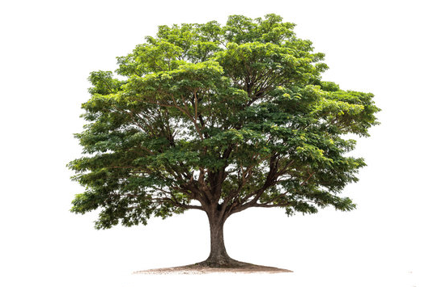

**Output:**

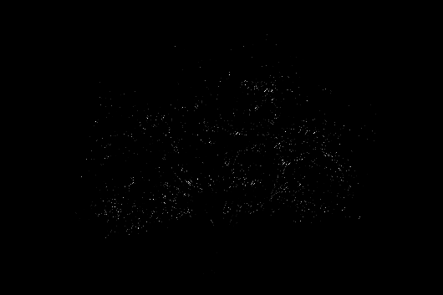

**Result:**

The python code to perform sharpening of image using Laplacian mask with positive centre coefficient has been executed successfully.